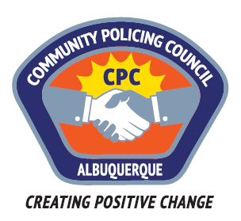

Valley Area Command Community Policing Council
AGENDA

May 24, 2018

6:00pm Call to Order
Determination of a Quorum
Approve April’s minutes and today’s Agenda

6:03-6:30 Report on APD Chief search, Chris Sylvan,
Discussion of concerns, input for recommendations, community
announcements.

6:30-7:30 Presentation on substance abuse treatment for homeless people by
Tim Bargas, one of the supervisors at the Bernalillo County
Assessment and Treatment Services Center, and Dr. Sara Doorley,
Medical Director, and George Mercer, Behavioral Health Clinical
Director, at Healthcare for the Homeless.

June 28th Meeting: TBA

The mission of each of the APD Area Commands’ Community Policing Councils is to promote positive, inclusive, respectful, supportive and cooperative interactions between diverse members of the community and the Albuquerque Police Department to ensure reforms are met and sustained.

